Mark Pratt

CST-247

7/16/20

Professor Pritchard

Activity 2 Part 2

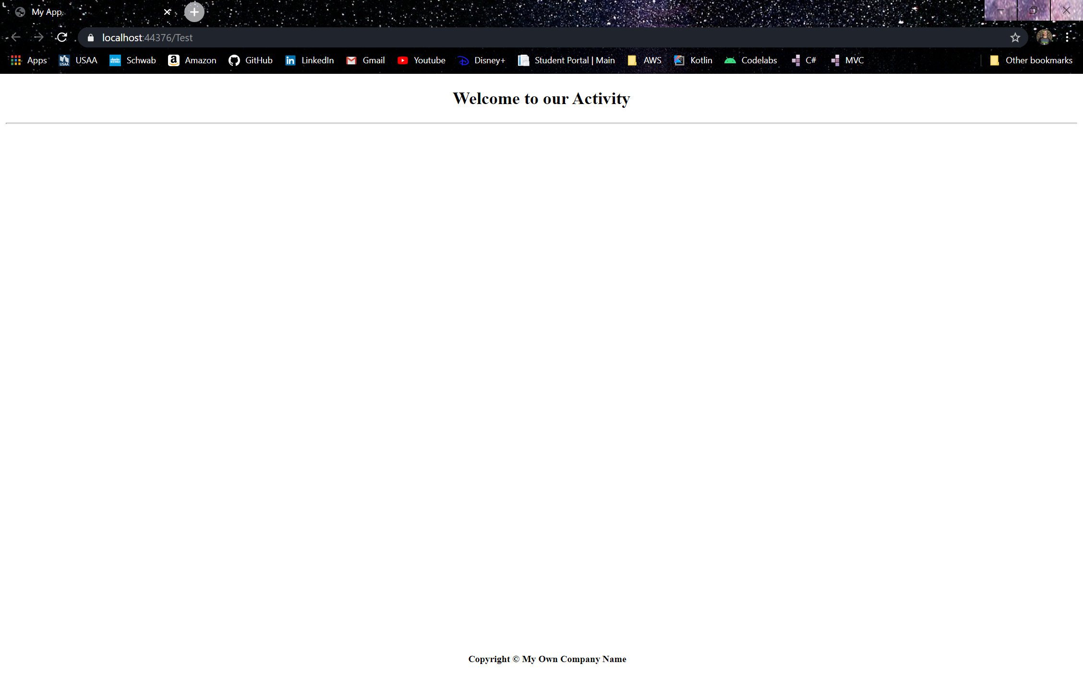

Screenshot 6

Added pages with razor

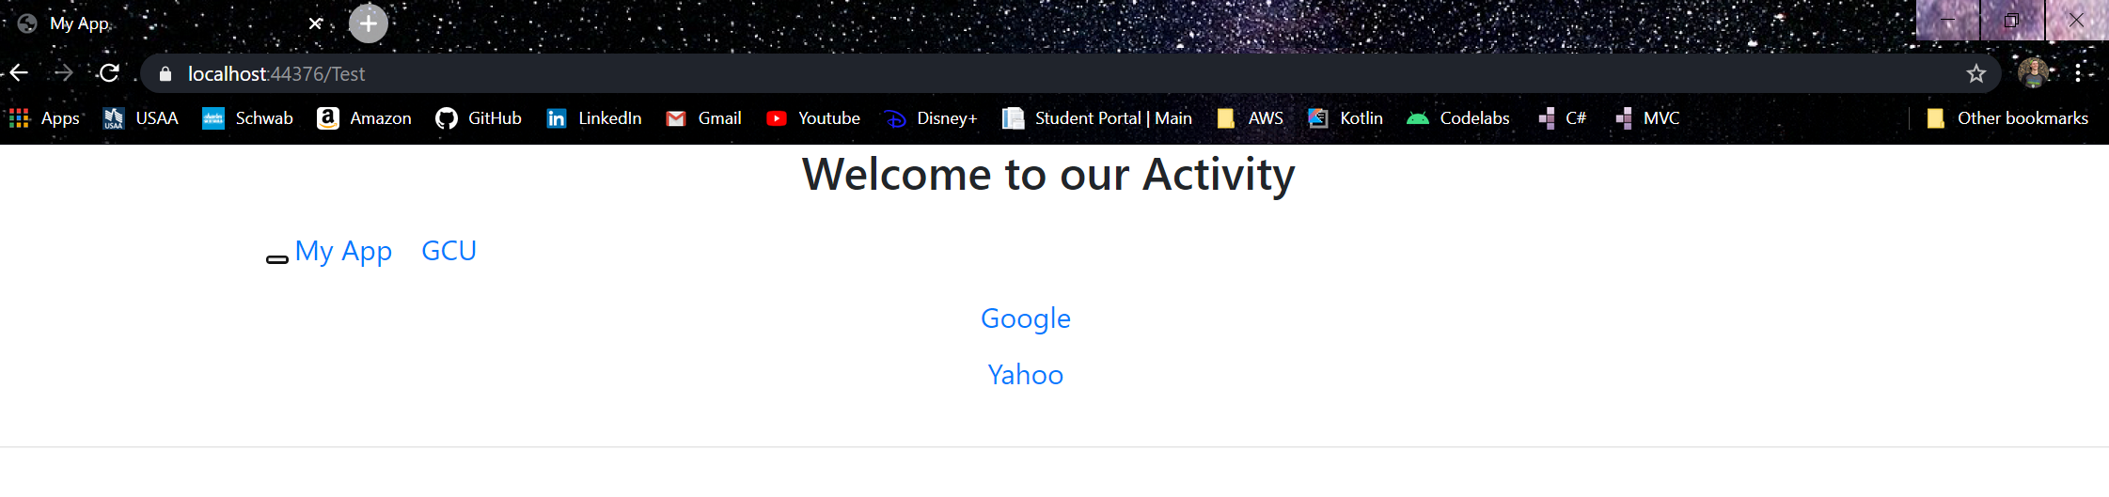

Screenshot 7

Added responsiveness and NAV bar with razor